Customized Logo Printed Ceramic Pots for Branding and Corporate Gifting
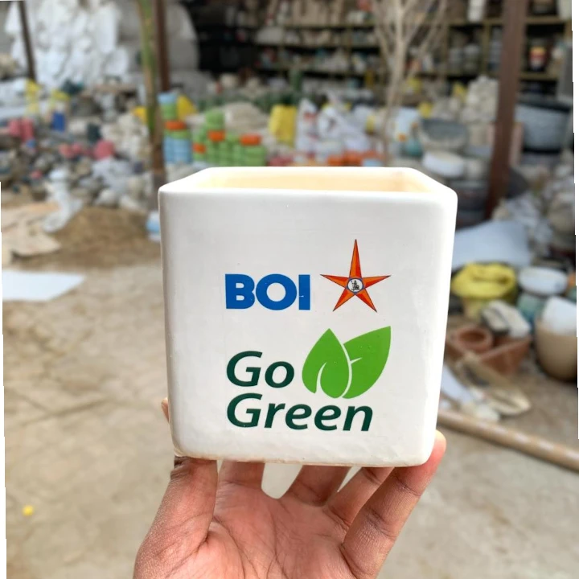
In today’s competitive business environment, branding goes beyond traditional marketing materials. Companies are increasingly choosing functional and aesthetic products to represent their brand identity. Customized Logo Printed Ceramic Pots have emerged as a popular choice for corporate gifting, promotional campaigns, and brand visibility. These pots combine practicality with elegance, making them suitable for offices, events, and long-term brand recall.
Ceramic pots with logo branding offer a premium feel that reflects quality and professionalism. Their durability and visual appeal make them ideal for businesses looking to create a lasting impression through thoughtful and sustainable gifting solutions.

Growing Demand for Customised Logo Printing Ceramic Pots
The demand for Customised logo printing Ceramic Pots has grown significantly across corporate sectors, hospitality brands, real estate projects, and event management companies. Unlike disposable promotional items, ceramic pots are reusable and long-lasting, ensuring continuous brand exposure.
Manufacturers use advanced printing and glazing techniques to ensure logos remain sharp, fade-resistant, and well-integrated with the pot’s design. This ensures that branding looks refined and professional while maintaining the natural beauty of ceramic material.

Corporate Pot With Logo Branding for Meaningful Gifting
A Corporate Pot With Logo Branding is more than just a gift; it represents a brand’s values and commitment to quality. These pots are commonly used for employee appreciation, client gifting, festive giveaways, conferences, and corporate events. When paired with plants, they symbolize growth, sustainability, and long-term relationships.
Ceramic logo-printed pots are available in various shapes, sizes, and finishes, allowing companies to choose designs that align with their brand aesthetics. Matte, glossy, textured, and minimalist finishes are especially popular in corporate gifting collections.

Customized Logo Printed Pots Wholesaler for Bulk Orders
For large-scale requirements, working with a reliable customized logo printed pots wholesaler is essential. Wholesalers specialize in handling bulk orders while ensuring consistency in design, logo placement, and finish. This is particularly important for corporate campaigns that require uniform branding across multiple units.
A professional wholesaler offers flexibility in order quantities, customization options, and production timelines. They also ensure proper packaging and safe delivery, making them an ideal partner for businesses and gifting agencies.

Ceramic Logo Printed Pots for Retail and Commercial Use
Ceramic logo printed pots are not limited to corporate gifting. They are also widely used by retail brands, cafes, hotels, resorts, and real estate developers. These pots help reinforce brand identity while adding a decorative element to spaces such as lobbies, offices, reception areas, and outdoor seating zones.
Ceramic material provides a premium look that enhances brand perception. Its strength and resistance to wear make it suitable for both indoor and outdoor use, ensuring long-term brand visibility.

What to Look for in a Ceramic Logo Printed Pot Manufacturer
When choosing a manufacturing partner, quality and customization capability are key factors. A reliable manufacturer ensures precise logo printing, strong firing, smooth glazing, and durable finishes. Attention to detail is essential to ensure that branding looks professional and long-lasting.
Production capacity and consistency are also important, especially for bulk orders. Experienced manufacturers can handle large volumes without compromising on quality or delivery timelines. Custom size options, color matching, and branding placement further add value to the final product.

DNF Ceramics: Trusted Manufacturer of Logo Printed Ceramic Pots in India
Businesses seeking a dependable sourcing partner can explore the ceramic logo printed pots manufacturer in India page of DNF Ceramics. The brand is known for its advanced manufacturing capabilities, high-quality ceramic finishes, and expertise in customized logo printing for corporate and bulk requirements.
DNF Ceramics focuses on combining design precision with durability, making it a preferred choice for businesses looking for premium ceramic pots with logo branding.

Conclusion
Customized ceramic pots with logo branding offer a perfect balance of functionality, aesthetics, and brand visibility. Partnering with an experienced manufacturer or customized logo printed pots wholesaler ensures access to high-quality products that align with corporate branding goals.
With durable materials, refined finishes, and precise logo printing, Customized Logo Printed Ceramic Pots and ceramic logo printed pots continue to be a powerful and elegant solution for corporate gifting and promotional branding.

